1. 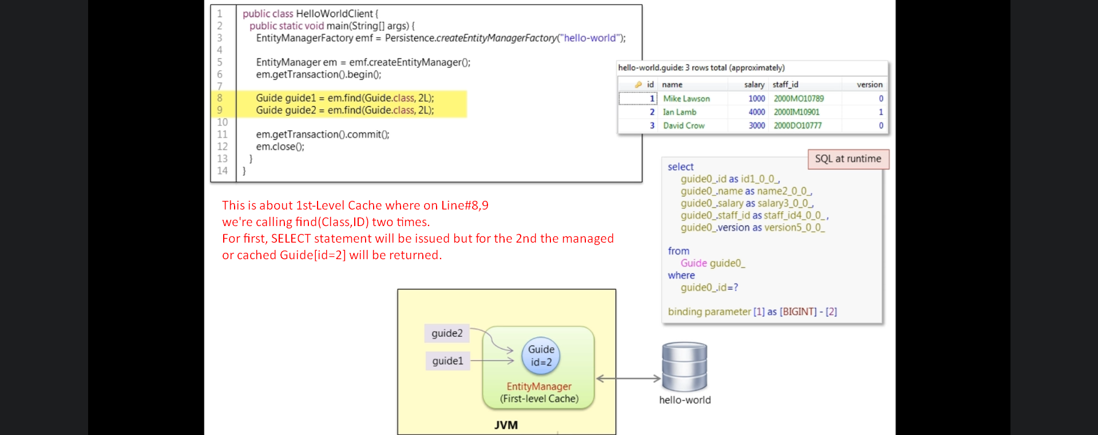
2. 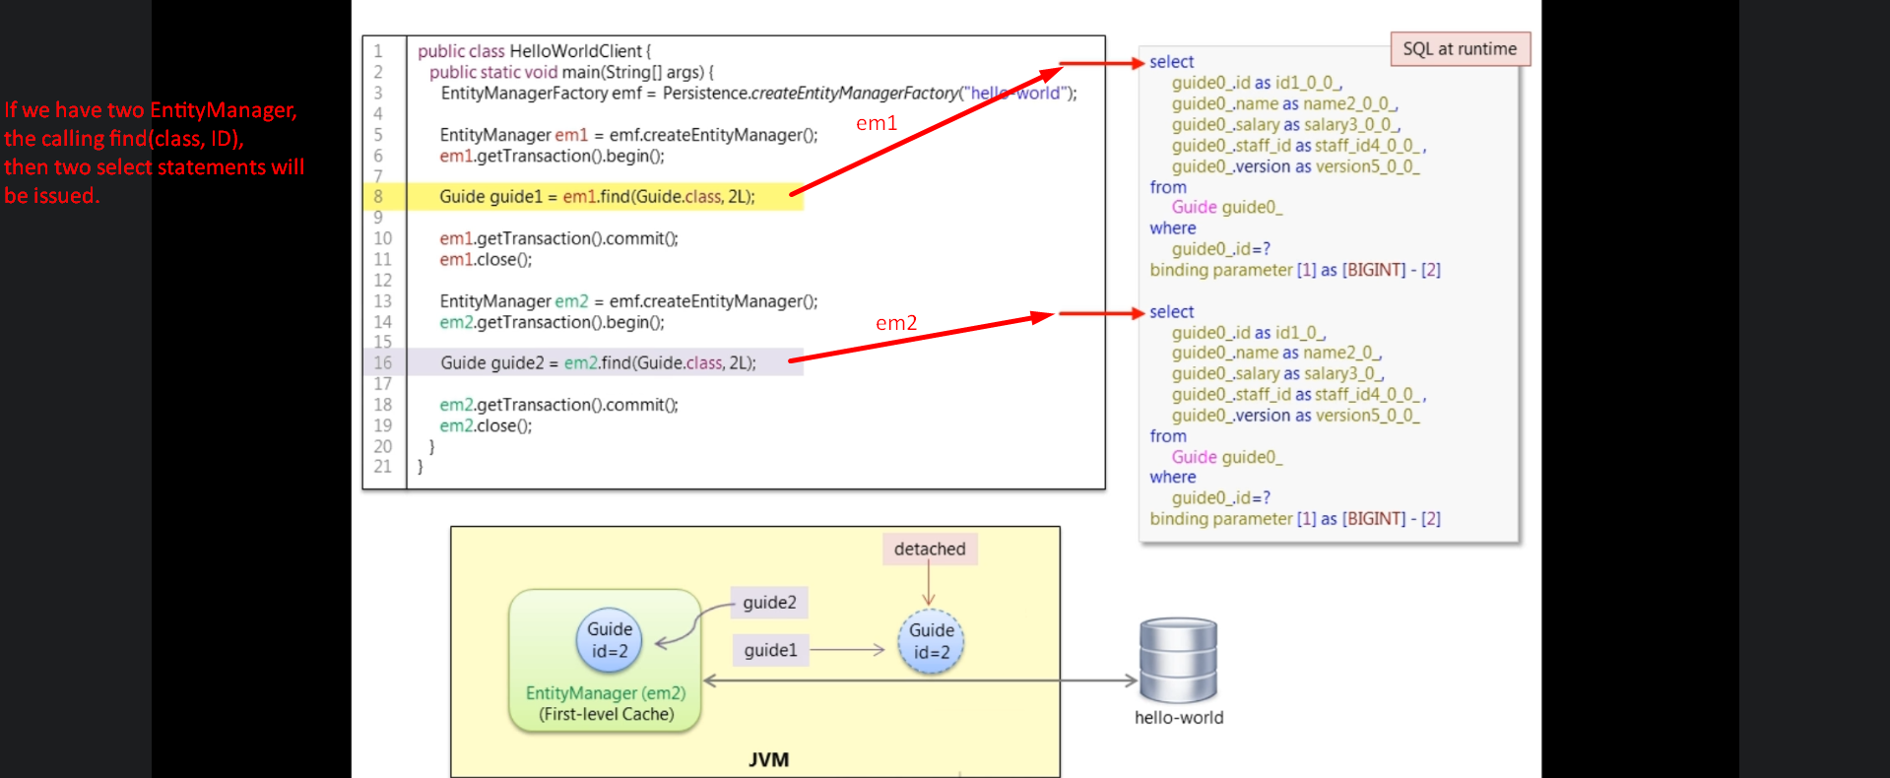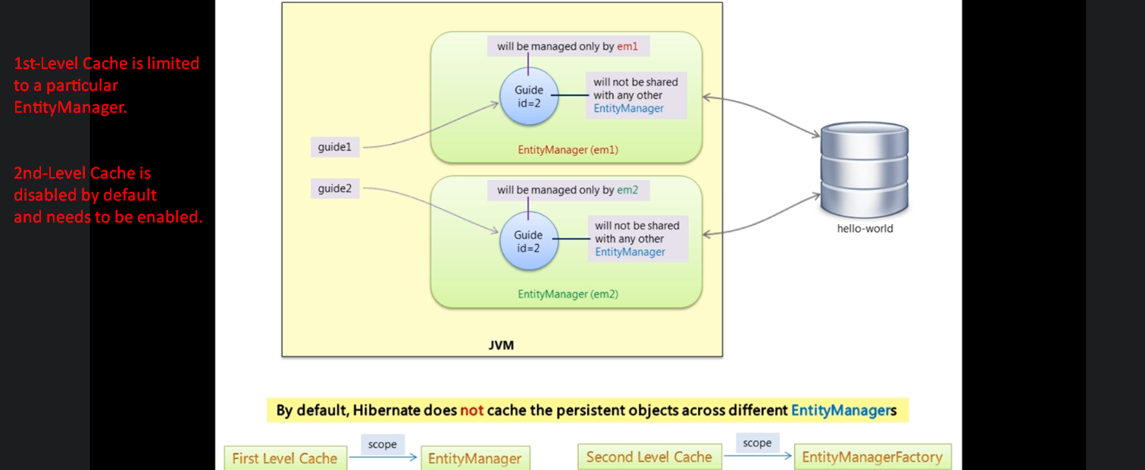
3. 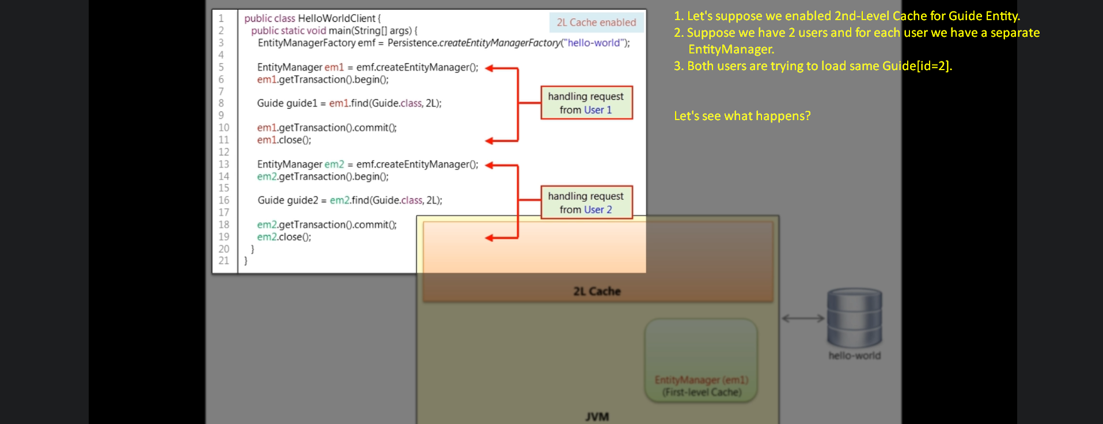
4. 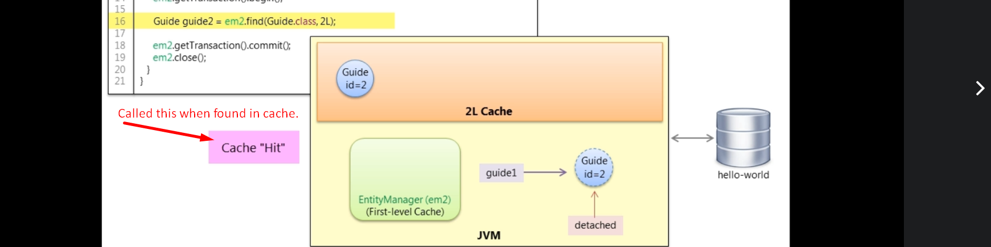
   1. First of all first level cache is looked into. If entity not found, then searching into 2nd-Level Cache.
   2. If not found even in 2nd-Level Cache, then SELECT is issued and entity is loaded in both caches.
   3. Cache Hit.
   4. 2nd-Level cache is managed by EntityManager Factory and that EntityManagerFactory will share this 2nd-Level Cache with its all EntityManager.   
      **NOTE**: One app can have EntityManagerFactory more than one. In that case 2nd-Level Cache by one EntityManagerFactory will not be shared with other EntityManagerFactory.